*Florida International University*

*School of Computing and Information Sciences*

Software Engineering Focus

Feature Document

User Story ID #197

Blog Page

**Name:** Nathally Perez

**Team Member(s):** Mariana Sebastian

**Project:** Driverless Car Website 1.0

**Product Owner(s)**: Kianoosh Gholami

**Mentor(s)**: Mohsen Taheri

**Instructor**: Masoud Sadjadi

**User Story Name:**Blog page

* As a user, I want to be able see posted articles about driverless cars on the website, so that I can be inform of any tips and tutorials about driverless cars.

Acceptance Criteria

* Web page should display articles properly.
* Web page should display pictures posted by the author.

**Use Case #**197

* Name:Blog page
* Actor:Site visitor
* Preconditions: Have access to the internet
* Description <Flow of events>:

1. Go to browser
2. Enter [http://localhost:3000](http://localhost:3000/)
3. Get request to server
4. Gets responds with homepage
5. Find blog bar on the navbar at the top of the page.
6. Clicks the blog tab in the navbar
7. Redirect to the blog page.
8. Find more information about tips and tutorials on driverless cars.

**Use Case Diagram:**

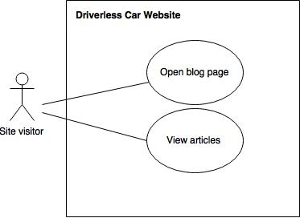

**Sequence Diagram**

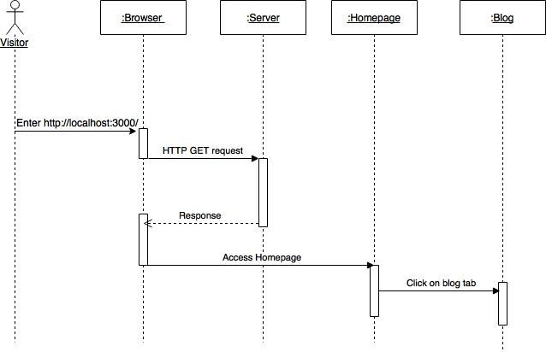

**Class Diagram**

N/A

**Unit Test**

**Test case 1(Sunny Day)**

* Test case ID: DCW-197-01
* Description/Summary of Test: Ensure that the blog page route is working properly.
* Pre-condition: The server is running on the localhost port 3000.
* Expected Results: Visitor is able to access blog page successfully
* Actual Result: Visitor was able to access blog page successfully.
* Status (Fail/Pass): PASSED

**Test case 2(Rainy Day)**

* Test case ID: DCW-197-02
* Description/Summary of Test: Ensure that the blog page route is working properly
* Pre-condition: The server is running on the localhost port 3000, but visitor lost internet access.
* Expected Results: Visitor is unable to access the blog page successfully.
* Actual Result: Visitor was not able to access the blog page successfully due to problem with connection.
* Status (Fail/Pass): PASSED

**Integration Test**

The integration test was made using postman and I tested the blog page and I did not have bugs and they were functioning correctly. The result were positive.

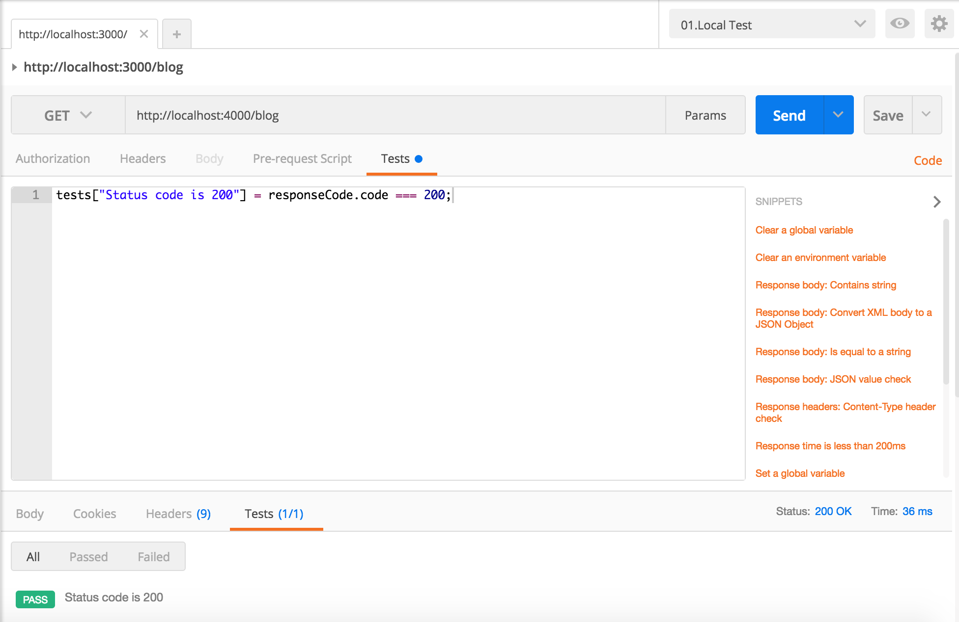

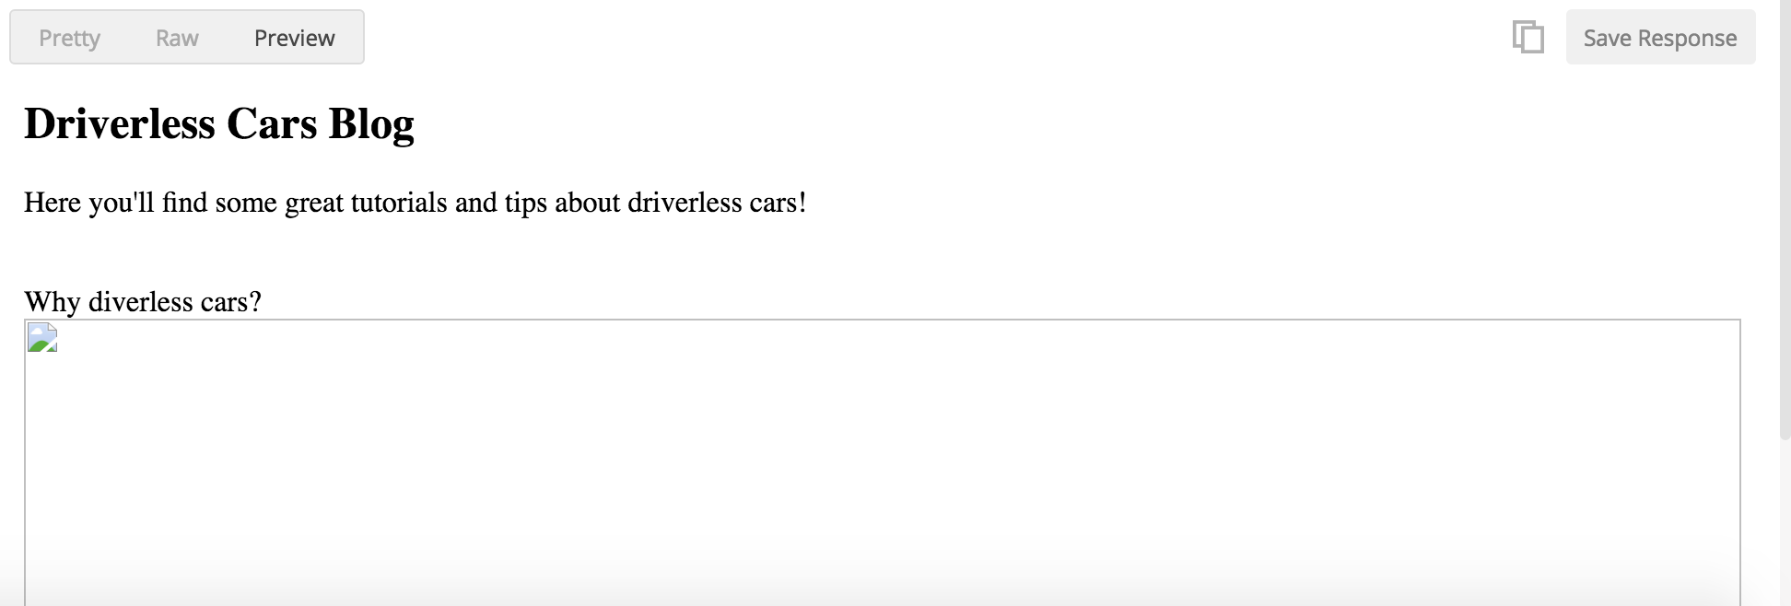

**Visual User Guide**

